**Educator’s Leadership Symposium - ITS Support**

1. Ensure that the web cam is connected.
2. Upload the presenter’s PowerPoint to the desktop.
3. Log in to Adobe Connect.

[https://gwynedd-mercycollege.adobeconnect.com](https://gwynedd-mercycollege.adobeconnect.com/)

1. Enter your **Username** and **Password**:

**Susan**

Username: Symposium1@gmercyu.edu

Password:  Sym1

**Jamel**

Username: [Symposium2@gmercyu.edu](mailto:Symposium2@gmercyu.edu)

Password:  Sym2

**Jeff**

Username: Symposium3@gmercyu.edu

Password:  Sym3

**Eddie**

Username: Symposium4@gmercyu.edu

Password:  Sym4

1. Click the **My Meetings** button at the top of the page.

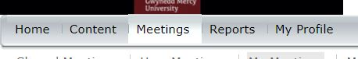

1. Click the name of the presentation.

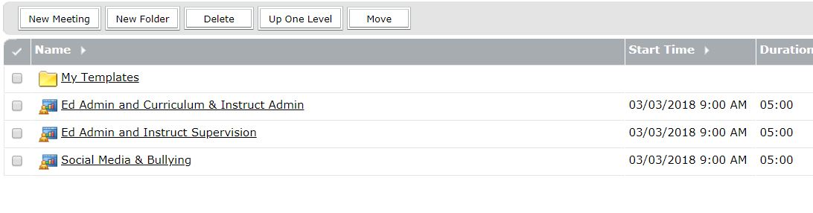

1. Click the **Enter Meeting Room** button (IMPORTANT: Do Not click the URL as that will take you into the meeting as the participant, not the host).

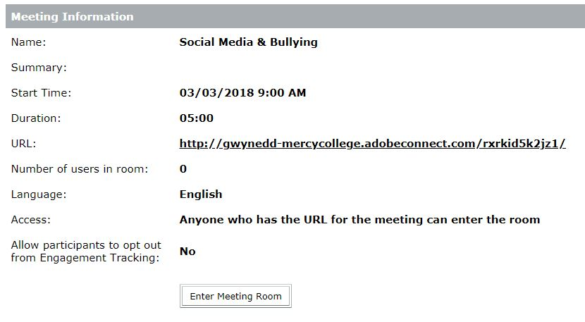

1. In the Adobe Meeting, click the **Meeting** option and select **Record Meeting**.

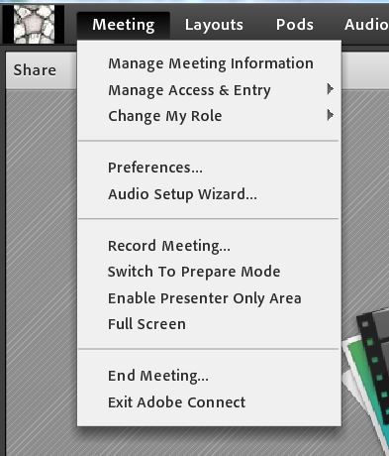

1. Click the **OK** button.

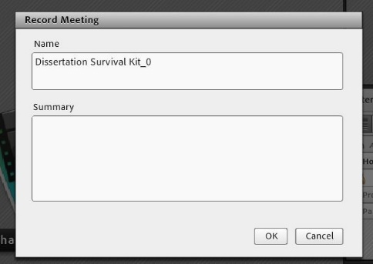

1. The meeting will start recording. Share the presenter’s presentation by clicking **Share My Screen**.



1. Click the **Share** button.

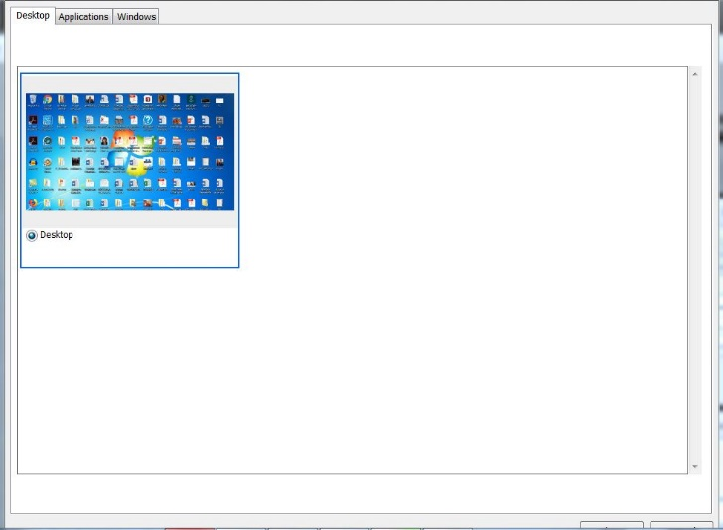

1. When the presenter has ended the presentation, click the **Desktop** icon, then click **Stop Sharing**.

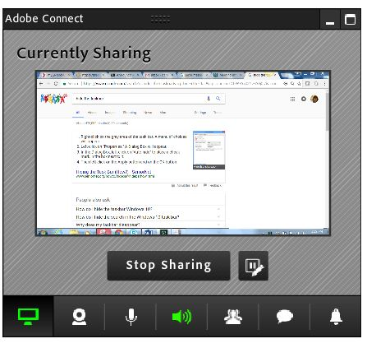

1. Click the **Red dot** and click **Stop Recording**.

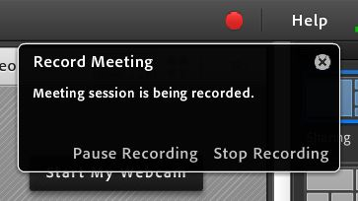

1. Repeat these steps for each presentation.

**Room Assignments and Session Details for Recording**

|  |  |  |
| --- | --- | --- |
| **Room W201 – Jeff** | | |
| **Session** | **Time** | **Presentation Title** |
| Session 1B | 10:00 – 10:30 | Social Media & Bullying |
| Session II | 10:45 – 11:45 | Ed Admin and Curriculum & Instruct Admin |
| Session III | 12:30 – 1:30 | Ed Admin and Instruct Supervision |
| **Room W205 – Susan** | | |
| **Session** | **Time** | **Presentation Title** |
| Session 1A | 9:30 - 10:30 | Students Who Have Experienced Trauma |
| Session II | 10:45 – 11:45 | Ed Admin and Secondary Principal Admin |
| Session III | 12:30 – 1:30 | Ed Admin and Elementary Principal Admin |
| **Room W112 – Jamel** | | |
| **Session** | **Time** | **Presentation Title** |
| Session 1 | 9:30 - 10:30 | Tools and Strategies for Planning |
| Session II | 10:45 – 11:45 | Roundtable on Current Issues in Higher Ed |
| **Room W116 – Eddie** | | |
| **Session** | **Time** | **Presentation Title** |
| Session 1 | 9:30 - 10:30 | The Comprehensive Assessment |
| Session II | 10:45 – 11:45 | Dissertation Survival Kit |
| Session III | 12:30 – 1:30 | Submitting the IRB Proposal |